ScopeCombination:

|  |  |  |  |  |  |
| --- | --- | --- | --- | --- | --- |
| Object Of Student and Address class | Student:  SingleTon,  Address:  SingleTon | Student:  ProtoType,  Address:  Prototype | Student:  ProtoType,  Address:  Singleton | Student:  Singleton,  Address:  Prototype  Real O/p | Expected O/p |
| Student1 | 101 | 101 | 101 | 101 | 101 |
| Address1 | 102 | 102 | 104 | 102 | 102 |
| Student2 | 101 | 103 | 102 | 101 | 101 |
| Address2 | 102 | 104 | 104 | 102 | 103 |
| Student3 | 101 | 105 | 103 | 101 | 101 |
| Address3 | 102 | 106 | 104 | 102 | 104 |

Single Scope will always create same hashcode if you call same bean multiple times by getbean() method.

ProtoType Scope will always create different hashcode if you call same bean multiple times by getbean() method.

For eg.

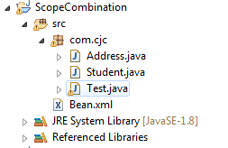

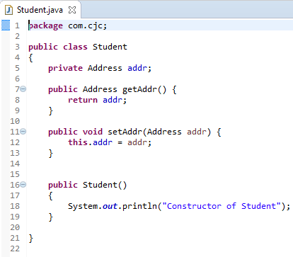

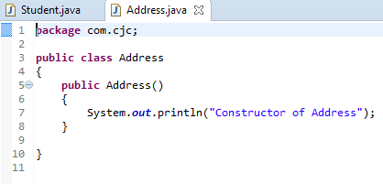

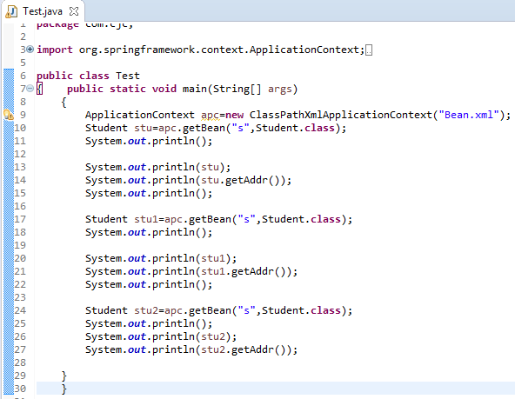

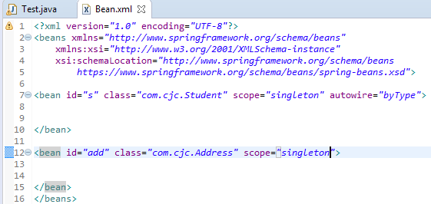

O/p:hash code for all student is f9 and for address is 7e that is hash code same for all objects.

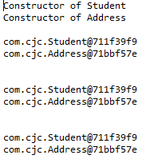

In scope Combination first three Scenario will work properly but last scenario of Student bean scope is singletone and address class bean scope is prototype so Output is not correct we can not get expected so to get expected O/p we have to use LookUp Method.

